Compsci235 Lab4 Report

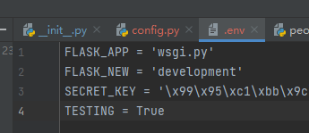**Task1**:create “config.py” and “.env” file as requested in the slide.

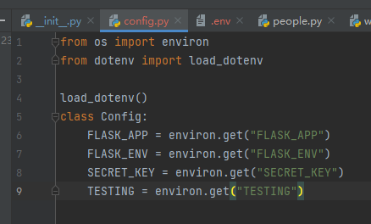

**Task2:** edit the “people_web_app/__init__.py”, edi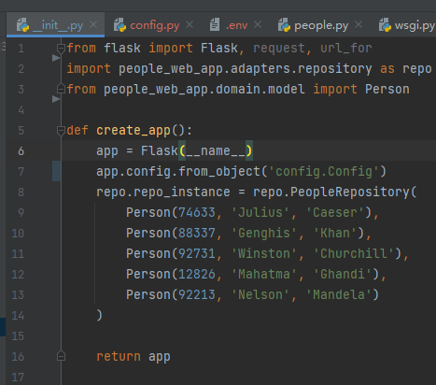t create_app() by adding “app.config.from_object(‘config.Config’)”

**Task3:** Create “home.html” and use similar layout as “list_people.html”.

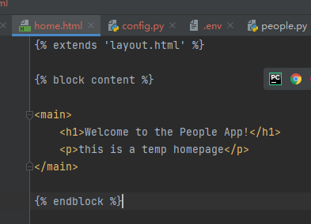

**Task4**: Create “list_person.html” to display a person’s detail (ID/name).

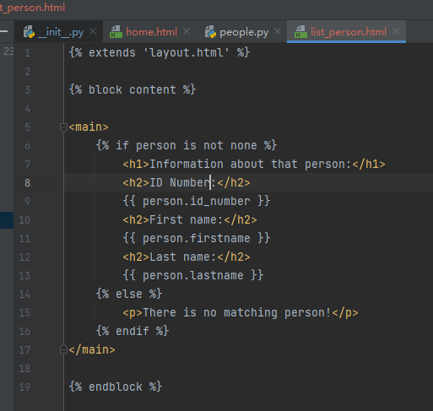**Task5**: edit “__init__.py” create_app() class, add following code to enable request of homepage. Result show below.

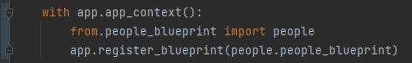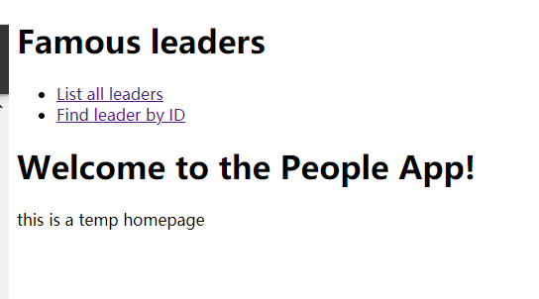

**Task6:** modified list_people() in “people_blueprint/people” to enable the “List all leaders” link.

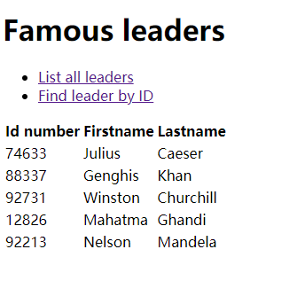

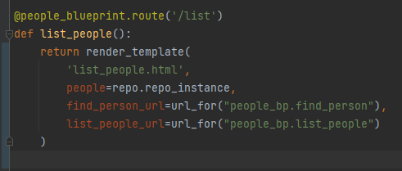**Task7**: WTF_CSRF_SECRET_KEY created by “print(os.urandom(24))” in python console.

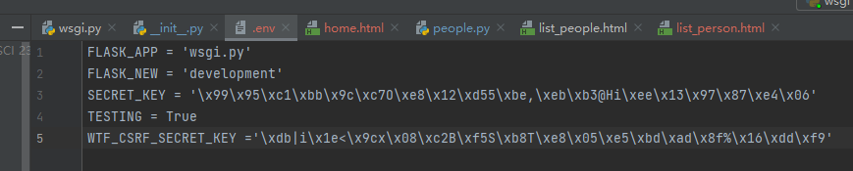**Task8**: Add following code into “people.py”.

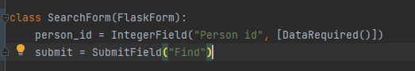

**Task9**: Create “find_person.html” which extends “layout.html”.

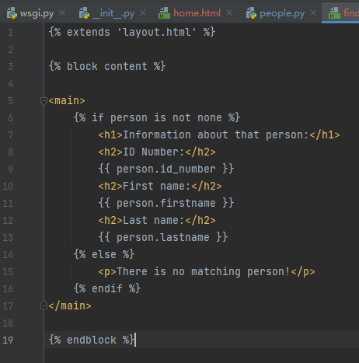**Task10**: